Plans

Microsoft offers various support plans that you can subscribe to.

There are five different support plans available in Azure:

1. Basic
2. Developer
3. Standard
4. Professional Direct
5. Premier

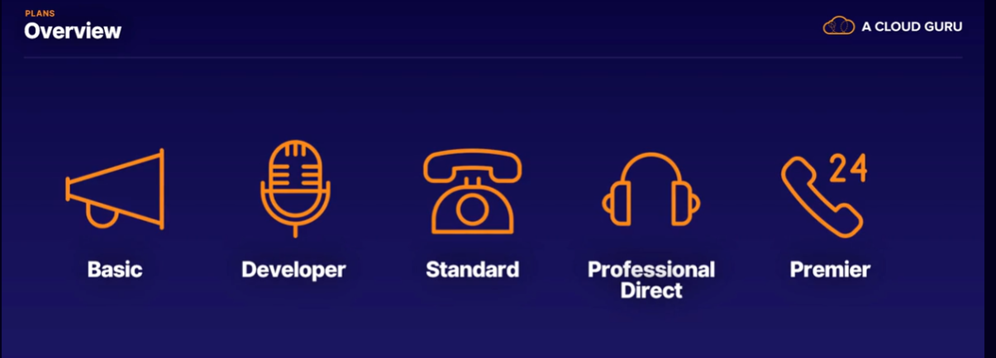

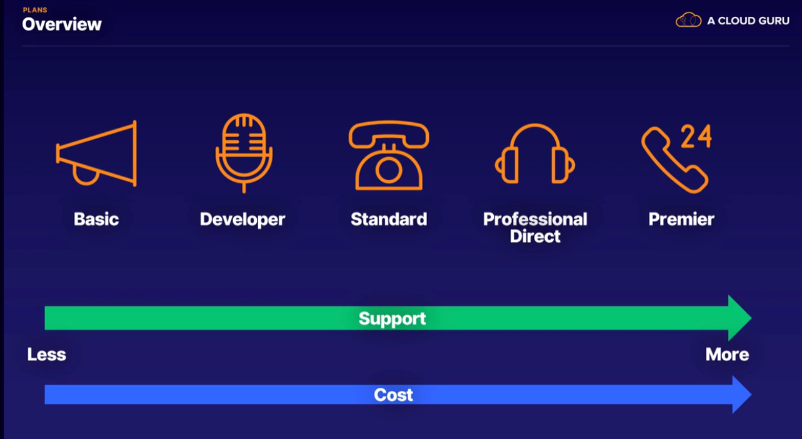

All plans supports::

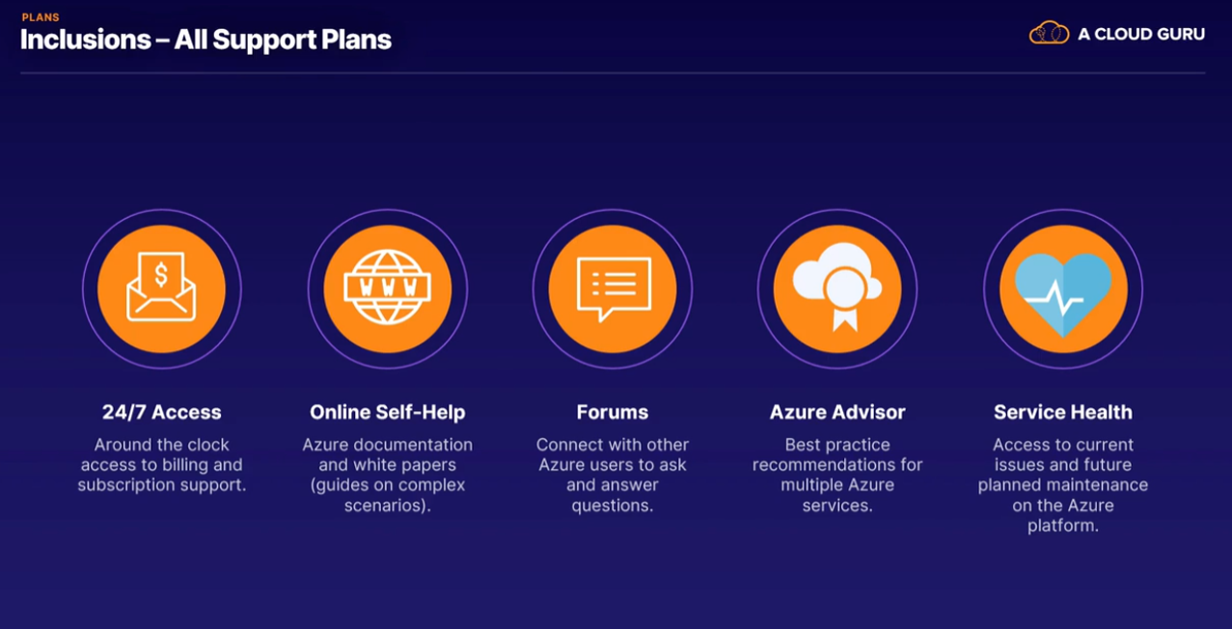

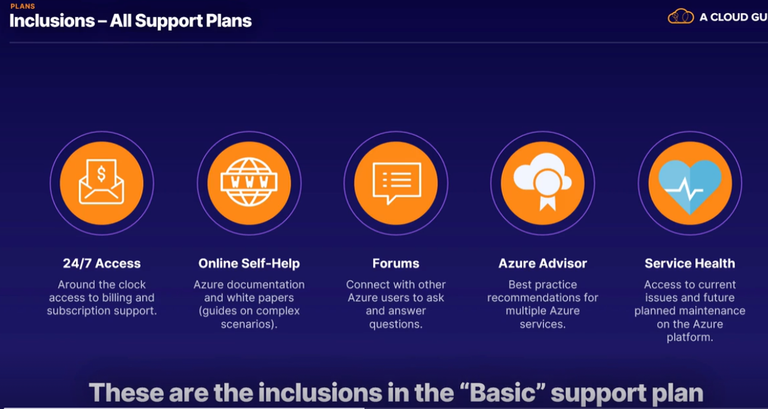

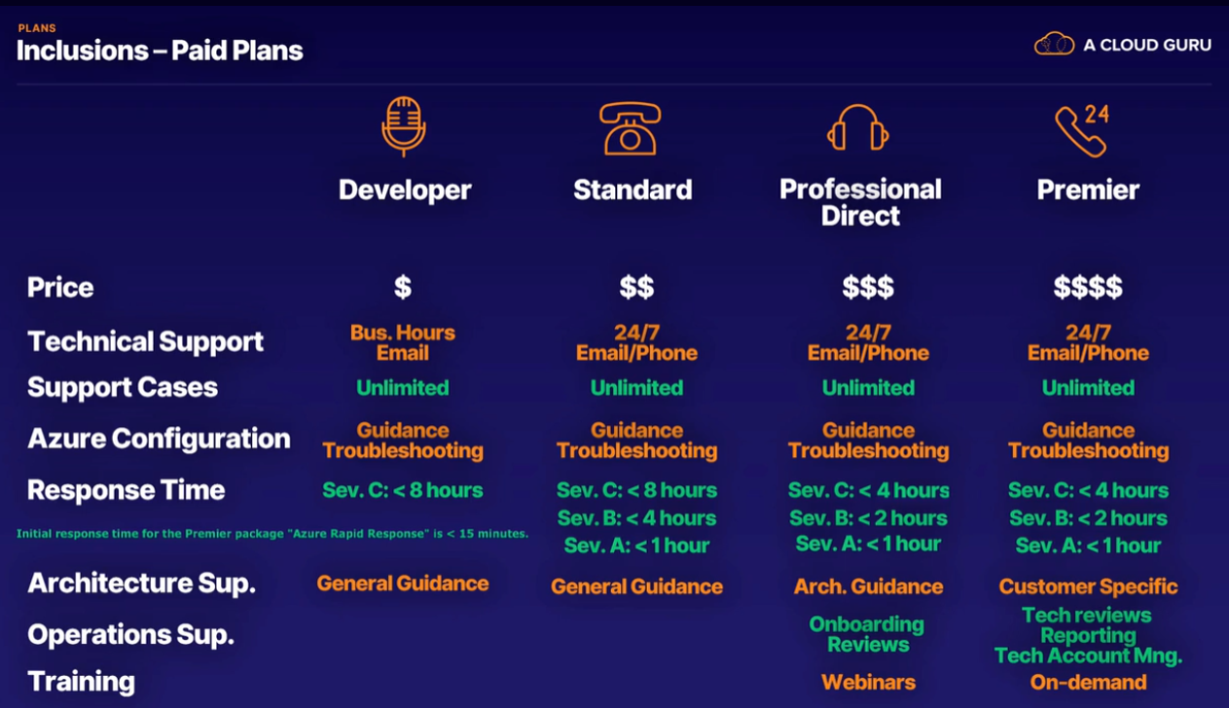

Minimal business impact (that's severity C)

Moderate impact (that's severity B)

Critical level (that's severity A)

Tickets

To contact Azure Support, we use the medium of tickets.

A ticket is usually a number that uniquely identifies your inquiry.

All communication and details of your support requests are recorded with the ticket number attached to them, so there is a single reference to the whole support request.

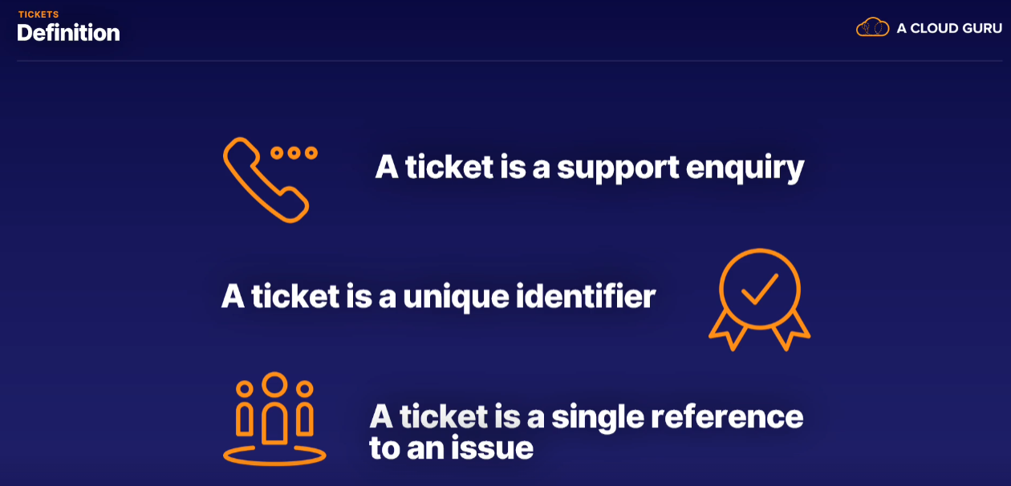

Submitting a Ticket::

* submit a ticket through the Azure portal
* You choose whether the issue is of type billing, service and quotas, subscription management, or a technical issue.
* Depending on which type of ticket you are creating, you asked to add additional details about the issue.
* once you submit a ticket, a Microsoft Support person will attend to your request within the specific times
* The more you pay, the higher a support plan you get, the faster you have your issues attended to.
* Remember, the Basic free support plan only allows you to create tickets to do with your subscription and billing. Nothing technical.

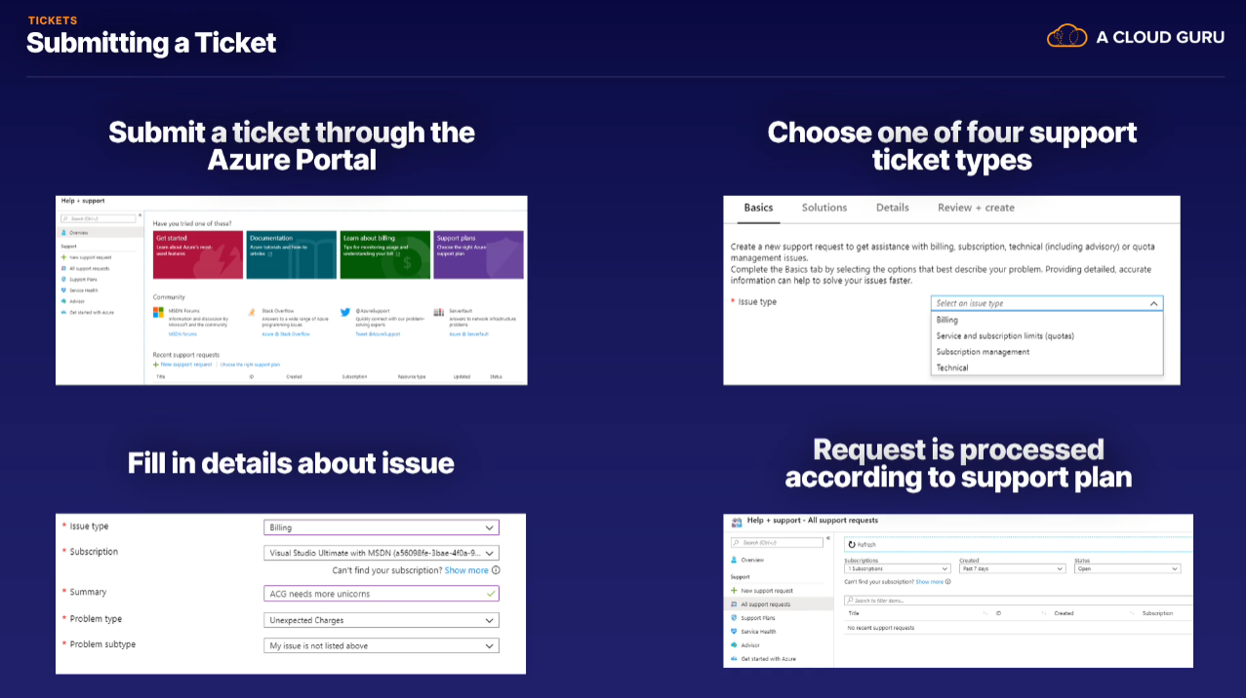

Channels

There are more ways to get help on Azure through the various channels available.

There are multiple ways of learning more about Azure and getting support than you might think.

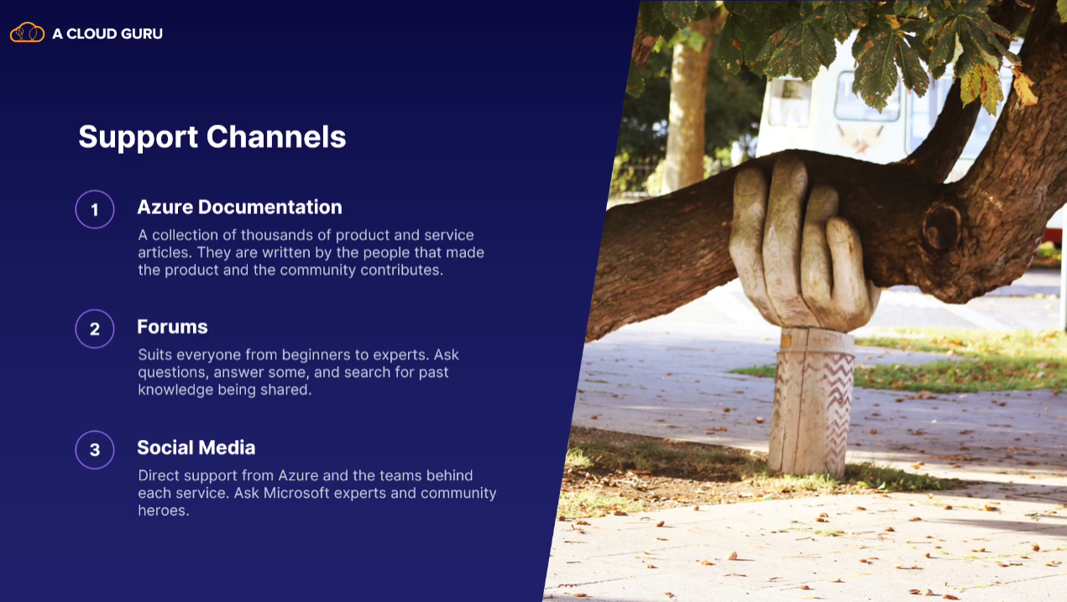

Azure Q&A

* You can’t ask your own questions or add to the knowledge base of the site
* But you can search for any question you would like

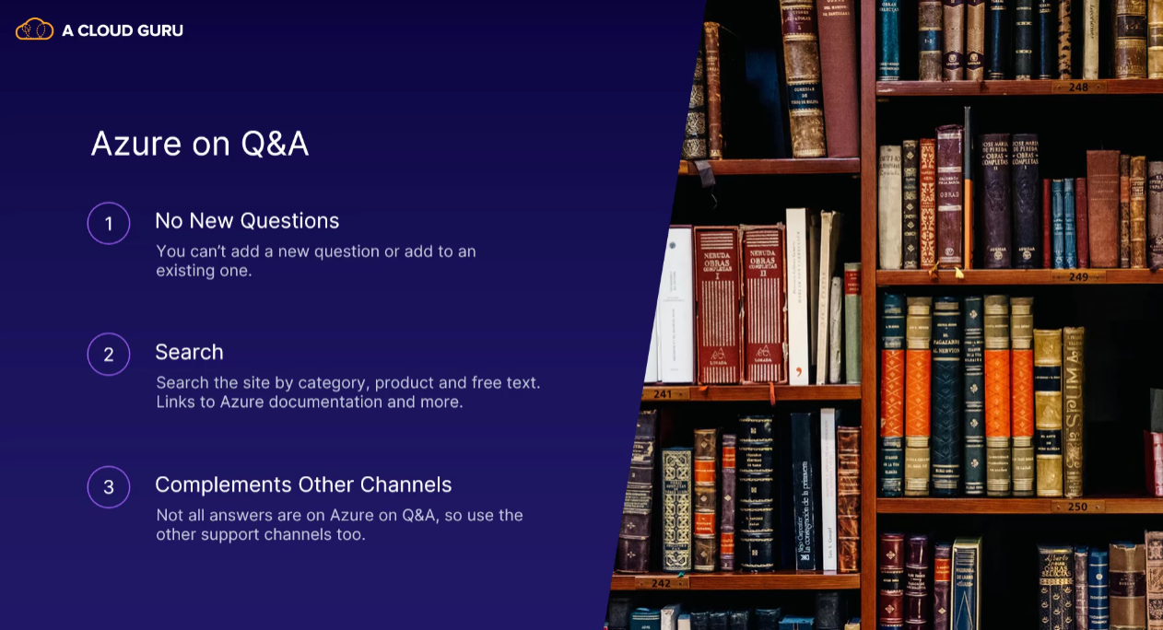

Service Level Agreement

When you use an Azure service, you want some form of guarantee that the servers will be running and that it's stable.

A service level agreement is a contract between a service provider and a client.

Now a service level agreement is a contract with the power company, or Azure, that states how long the power can be out or the service down.

If a service is not working for more than an agreed period of time in a month, you can claim compensation from Microsoft.

You pay for an SLA, which is what service level agreements are often called, to ensure the least possible downtime of a service. It's like insurance.

If there's a breach of the SLA, you can claim.

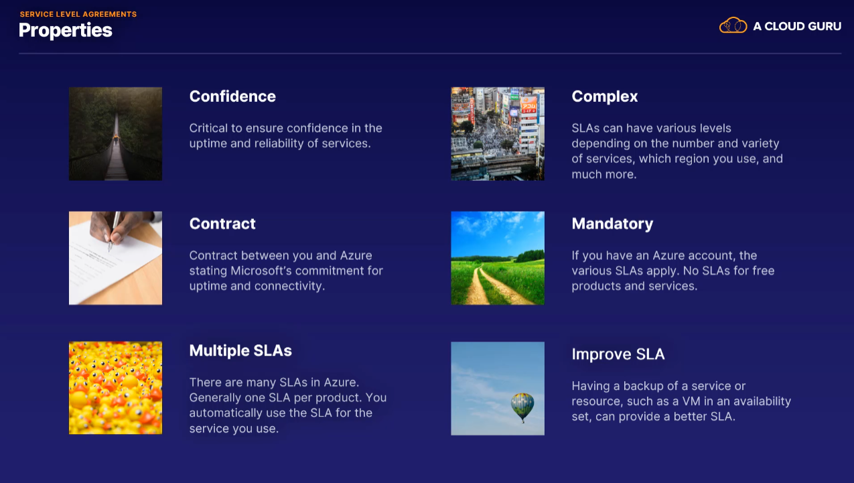

Service Life cycle

Every product and service on Azure has a start in life called the service lifecycle.

When services are developed by Microsoft for the Azure platform, at times it can be necessary to ask the customers, the actual people that will be using the service, for help.

Customers can provide valuable feedback about features and functionality before everything is set in stone and before Microsoft has made a large investment into that product.

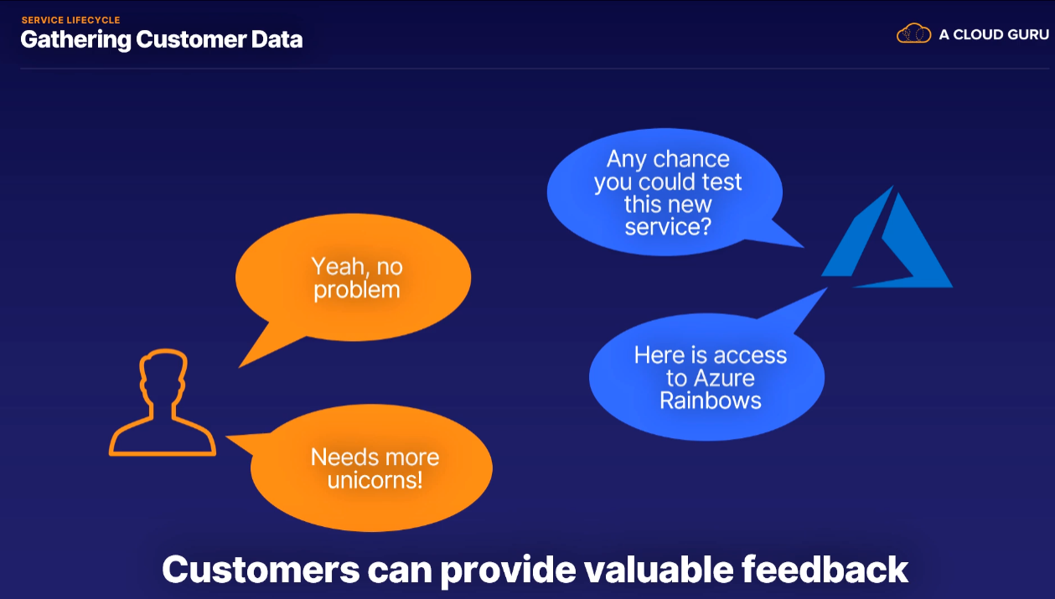

There are main 3 stages in life cycle

* Preview
* Most of the Azure products will go through a preview phase before becoming full-grown, adult Azure services.
* Some will start in private preview stage
* Some will start in public

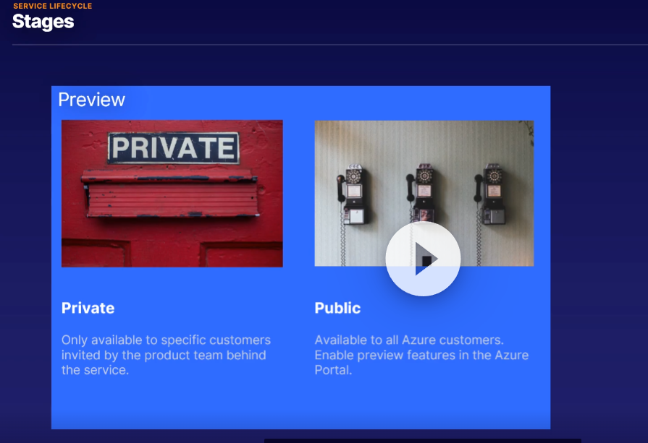

* General Availability
* It means an Azure service is generally available to all Azure customers.
* The service has an SLA, a support team, and anything else that goes with an adult Azure service.
* A service will go into general availability when the product team behind it decides it is ready.

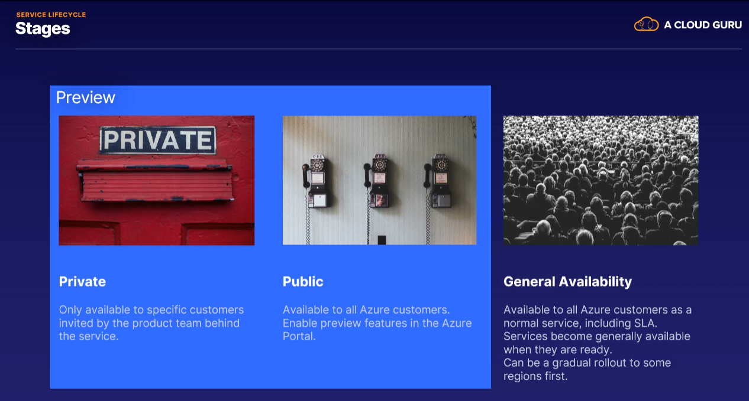

* The rollout to general availability can happen gradually to some regions first before going fully global.

